LSTM model Epoch Accuracy

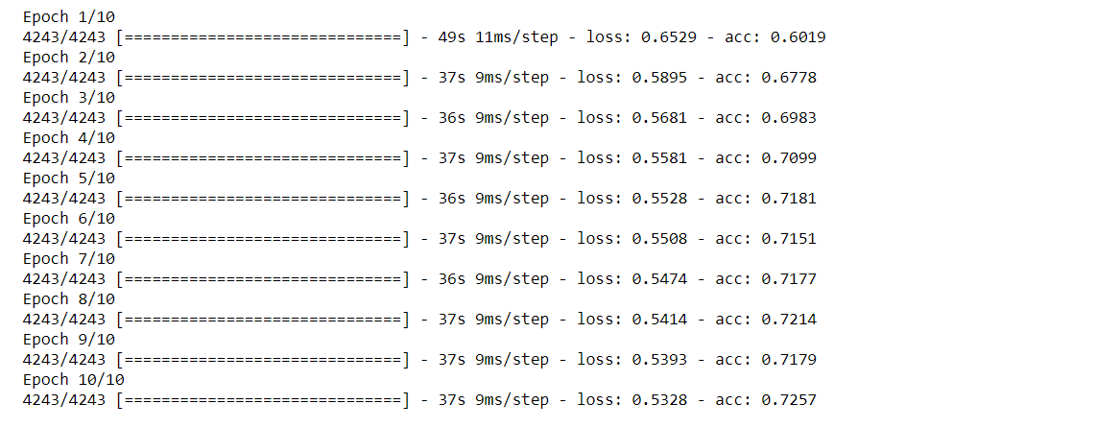

ANN model Epoch Accuracy

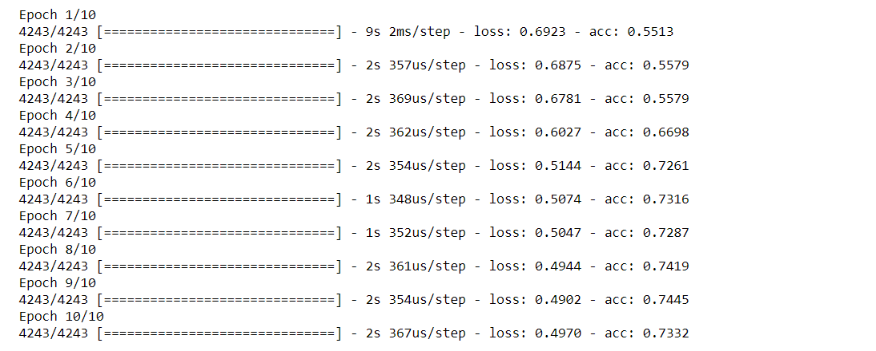

LSTM Classifier Report

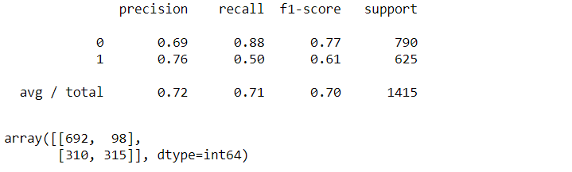

ANN Classifier Report

